PATIENT NAME: Wilma Leola Washington Boyd (F)
INSURANCE ID#: 2E17H10GR33 DOB: 07/13/1935
ADDRESS: 3633 Breakers Dr, Olympia Fields, IL 60461
PHONE #: (773) 213-2556
MEDICARE DESCRIPTION AND PROCEDURE CODES:
- POWER WHEELCHAIR GROUP STANDARD CAPTAIN CHAIR - K0823 ;
- BATTERY - E2365

VISION SPORT P322
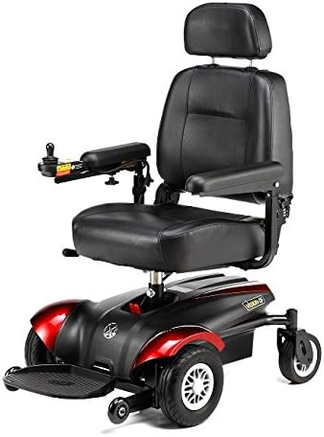
Mid-wheel drive design provides outstanding maneuverability in tight, compact spaces.
- Patented articulation mechanism allows front wheels climbing up the step/ threshold easily.
- Low center of gravity provides a smooth and stable ride both indoors and outdoors.
- Dual in-line motors for enhanced efficiency, torque, range and performance.
- Full suspension design offers a comfortable ride.
- Swing back controller bracket is standard.
- Height and width adjustable armrest, semi reclining backrest and height adjustable seat.
- Excellent stability on footplate.

Driving Range | 29 km / 18 mi.
Max Speed | 8 km/h , 5 mph
Battery Type | 12V U1x 2 pcs
Motor | DC 24V , 160W (Rating) / 520W (Max)
Max Climbing Angle | 6°
Turning Radius | 51 cm / 20"
Ground Clearance | 5 cm / 2"
Controller | PG nVR2 50A / DY LiNX
Charger | 4A off-board
Weight Capacity | 136 kg / 300 lb
Total Weight | 84 kg / 185 lb
Front wheel | F/R 6" x 2” PU tire
Drive Wheel | 10” (260 x 85) Foam filled tire
Rear wheel | F/R 6" x 2” PU tire

**Patient Agreement:** I, ___________________________________ (Patient Name), acknowledge that I have reviewed the power wheelchair depicted in the accompanying picture. I understand its features and specifications and agree that this wheelchair meets my mobility needs as assessed by my healthcare provider. I consent to accept and use this specific power wheelchair as part of my mobility solution.

Patient’s Signature:___________________________________________________________ Date:_____________
Signature if other than patient:___________________________________Relationship:_____________________
Name if other than patient:_______________________________________________________________________
Reason patient is unable to sign:__________________________________________________________________
Evaluator’s Signature:_____________________________________________________ Date:________________
Evaluator’s Name (printed):______________________________________________________________________

